**NNFL EXPERIMENT 10**

**CODE:**

clc

clear all

close all

img=imread('rice.png');

figure(1)

imshow(img)

img=double(img(:))';

p=img(1,1:80);

net=newsom(minmax(p),[1 2]);

net1=train(net,p);

y=sim(net1,img);

final=reshape(y(1,:)*256,[256 256]);

figure(2)

imshow(final)

**NETWORK:**

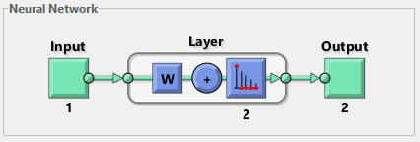

**OUTPUT:**

Original image:



Image Classified using SOM:

